Graphics Lies & Misleading Visuals

# Assignment

1. locate and identify a visual that displays misleading information
2. Identify mechanisms for misleading i.e. hiding relevant data, displaying too much data and obscuring reality, and distorting data through graphic forms
3. explain how it was used to mislead.

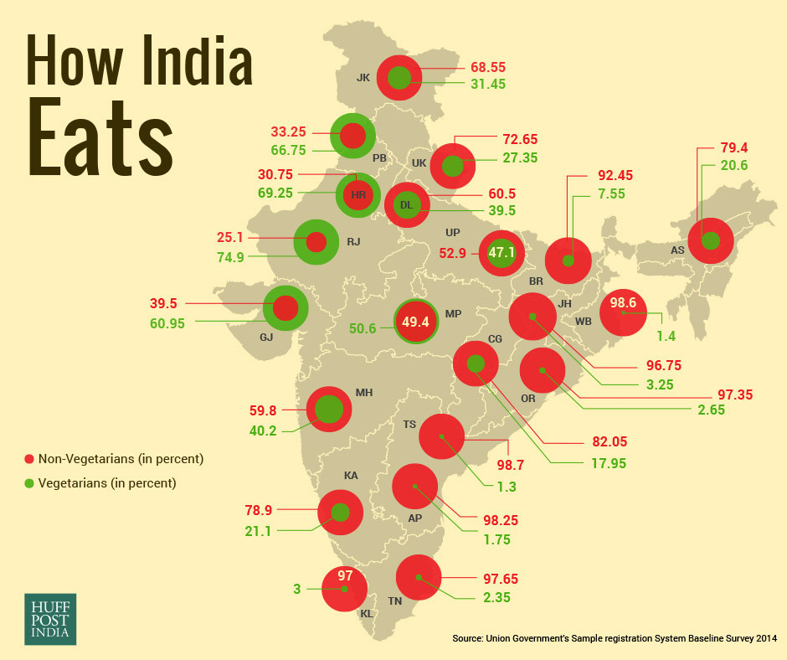The infographic belongs to an American news and opinion website article titled *'Vegetarian India A Myth? Survey Shows Over 70% Indians Eat Non-Veg, Telangana Tops List'*. This article argues that over 70% percent of the Indians are non-vegetarian against the common belief that India is a vegetarian country. The image is also strengthened by honorable Indian Prime Minister who is also a vegetarian.

The visualization was also featured in WTF Visualizations tumblr thread. http://viz.wtf/post/162284459410/circleception

**Source**: http://www.huffingtonpost.in/2016/06/14/how-india-eats_n_10434374.html

**Intended Audience**: *Indian Lifestyle content consumers***.** The article was meant to inform people about eating patterns. This was Indian Edition and article was posted under lifestyle section, which means it was meant primarily for individuals who consume more lifestyle content.

# Misleading Components

* **Component 1**: Title of the Infographic
* **Mechanism**: ﻿Hiding Relevant Data
* **Explanation**: The Infographic does not give any clear measure of consumption of non-veg food whether it is on a per week or per month basis﻿. The designer could have included the definition of a vegetarian / non-vegetarian.
* **Component 2**: Size of the circles
* **Mechanism**: ﻿Distorting the data
* **Explanation**: The percentage measure uses constant size circles with variable areas of red (non-veg) and green (veg). The size of the circle according to the designer is meant to represent 100% but in this case for state MP it is representing 50.6% and 98.7% in case of Telangana. For the state MP which is supposed to have almost equal proportion of non-veg and veg individuals seems to be dominated by non-vegetarians because of size of red